Database Migration Note -:

-- Change Connection String as per your Machine Requirement ---

Path :- Project > AirportDemo > appsettings.json

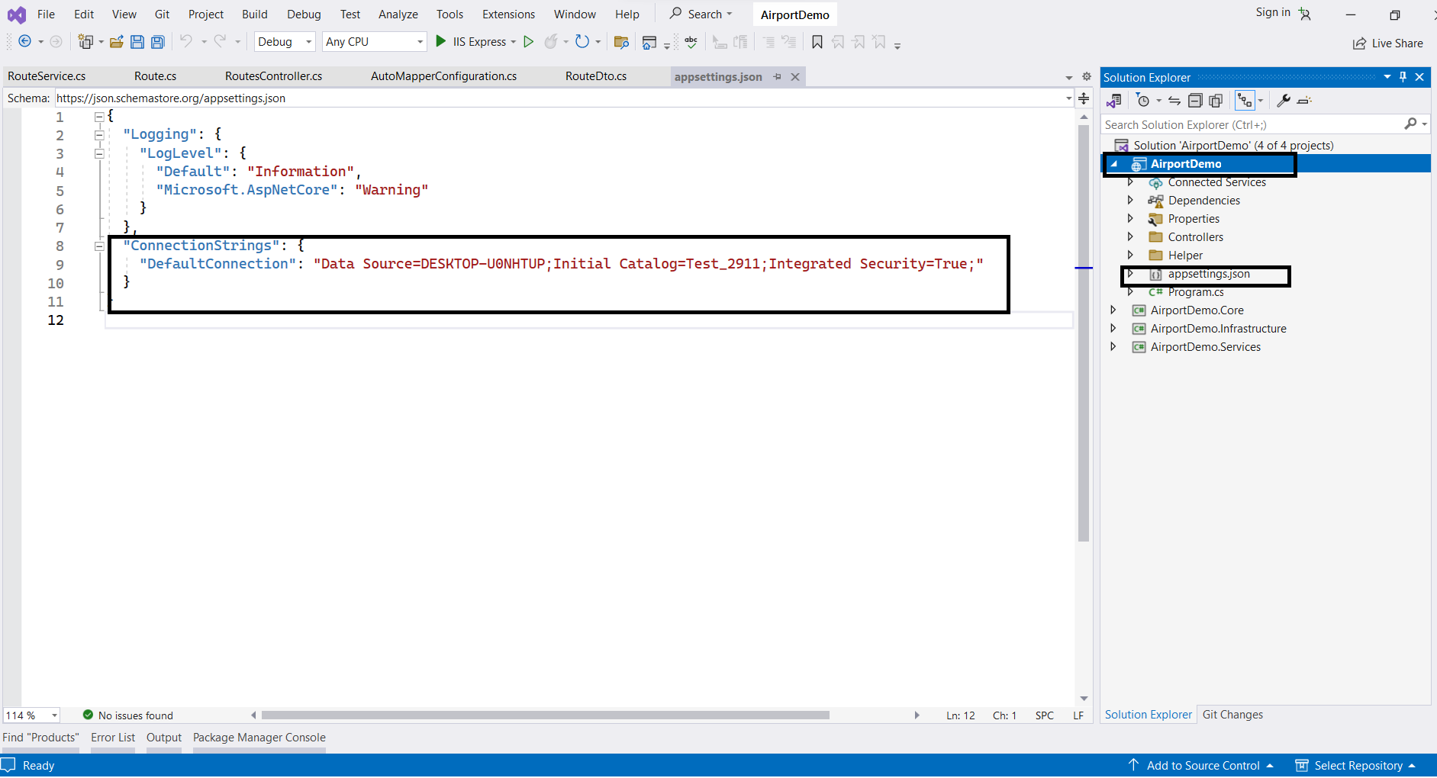

1) Open Tools > NuGet Package Manager > Package Manager Console

2) Then Select Default Project > AirportDemo.Infrastructure

2) Trigger Command

- add-migration Initial (Then Click)

- update-database

